**PF THEORY ASSIGNMENT 7**

**Question#01**

**Write a program that globally declares and assigns 10 integer values in an array and using UDF generates the table of each value present in array elements.**

**SOURCE CODE**

**#include<iostream>**

**using namespace std;**

**int tablearray[11];**

**void printtable (int a)**

**{**

**for(int i=0; i<=12; i++)**

**{**

**cout<<i<<" * "<<a<<" = "<<i*a<<endl;**

**}**

**}**

**int main()**

**{**

**cout<<"Enter a 10 numbers: "<<endl;**

**for(int i=0; i<=9; i++)**

**{**

**cin>>tablearray[i];**

**}**

**for(int i=0; i<=9; i++)**

**{**

**printtable (tablearray[i]);**

**}**

**return 0;**

**}**

**OUTPUT**

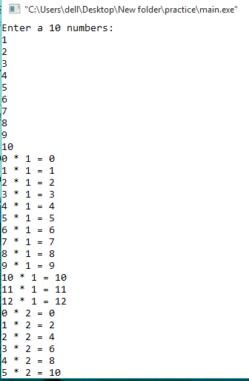

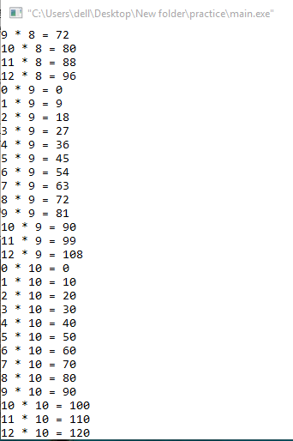

**Question#02**

**Write a program code for the following given scenario in which multiple UDF calls each other.**

**SOURCE CODE**

**#include<iostream>**

**#include <math.h>**

**using namespace std;**

**int sum;**

**int udf1(int, int ,int);**

**int udf2(int);**

**int udf3(int, int, int);**

**int udf1 (int a, int b, int c)**

**{**

**int x,y,z;**

**x=udf2(a);**

**y=udf2(b);**

**z=udf2(c);**

**sum=udf3(x, y, z);**

**cout<<"THE PRODUCT OF THE SQUAREROOTS IS "<<sum;**

**}**

**int udf2 (int j)**

**{**

**return(sqrt(j));**

**}**

**int udf3 (int x, int y, int z)**

**{**

**return(x*y*z);**

**}**

**int main()**

**{**

**int a,b,c;**

**cout<<"Enter 3 numbers: "<<endl;**

**cin>>a>>b>>c;**

**udf1(a, b, c);**

**return 0;**

**}**

**OUTPUT**

